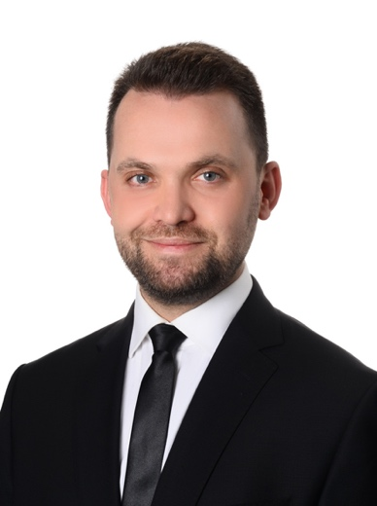
Dr. Mehmet Erdogan
Smile Hair Clinic – Co-Owner – Hair Transplant Surgeon

Dr.Mehmet Erdoğan received his medical degree with honors from the University of Yeditepe School of Medicine , Istanbul. He spent 4 years hands on surgical experience by hundreds of International Patientoverall the world.

Actively participating of Hair restoration Surgeries since 2013 with advanced method of Follicular Unit Extraction (FUE) technique. He has created a practice dedicated exclusively to providing the very best hair
loss treatments, including surgical or medical treatments for hair loss. His care for his patients supported by an exceptionally experienced team of hair specialist surgeons, hair specialists and trichologists specialized in hair replacement surgery. He has always gravitated towards the surgical aspect of his specialties but also enjoys the relationships he develops with his patient.

Expertise
Hair Transplantation
Experience
2013- Hair Transplant Surgeon
2016 - 2018 Medicana Health Group International Relations and Marketing Director
2014 Medical Doctor - Kadikoy Hospital, Istanbul ,
2013 - 2016 Medicana Çamlıca Hospitals, Deputy Medical Director
2013 -2013 Medical Doctor - Acıbadem Health Group
2011-2013 Medical Doctor - Beykoz State Hospital, Istanbul,
Education
2017 Mesotherapy Certification
2017 Phytotherapy Certification
2017 American Heart Association ACLS (Adult Cardiac Life Support)
2013 Medical Aesthetician Course, Hair Transplantation Course
2011 - ongoing Anadolu University, Hospital Management
2011 Yeditepe University Medical School, Istanbul
Memberships & Professional Achievements
- Associate member of ISHRS
- Istanbul Society of Doctors Association
- Turkish Healthcare of Travel Council - Board Of Directors

Languages Spoken
Turkish
English
German

